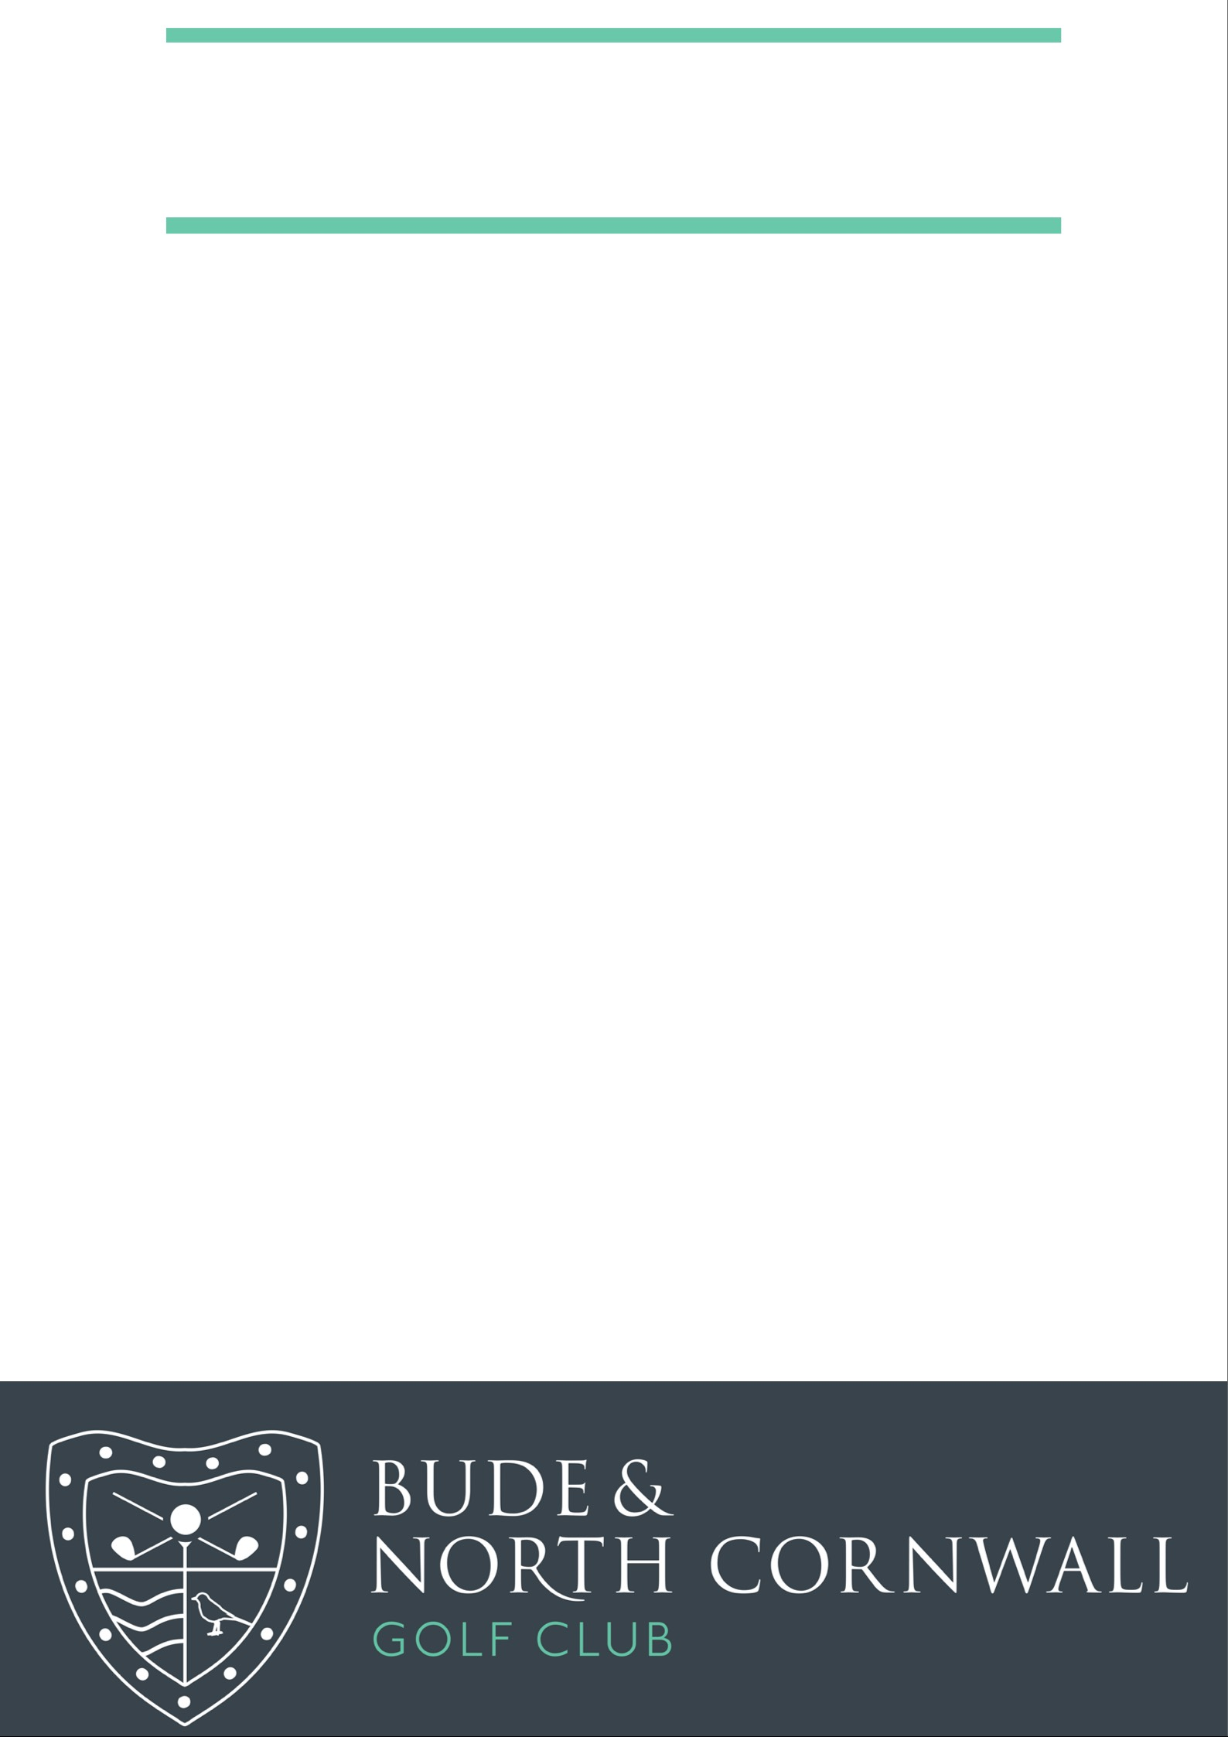

**Aria Resorts – Junior Day**

**Results**

**1st**

**Connor Vanstone**

**36 Points**

**2nd**

**Sophie Page**

**34 Points**

**3rd**

**Kenanne Burt**

**34 Points**

**4th**

**Morgan Bryant**

**34 Points**

**5th**

**Lowen Stephens**

**32 Points**