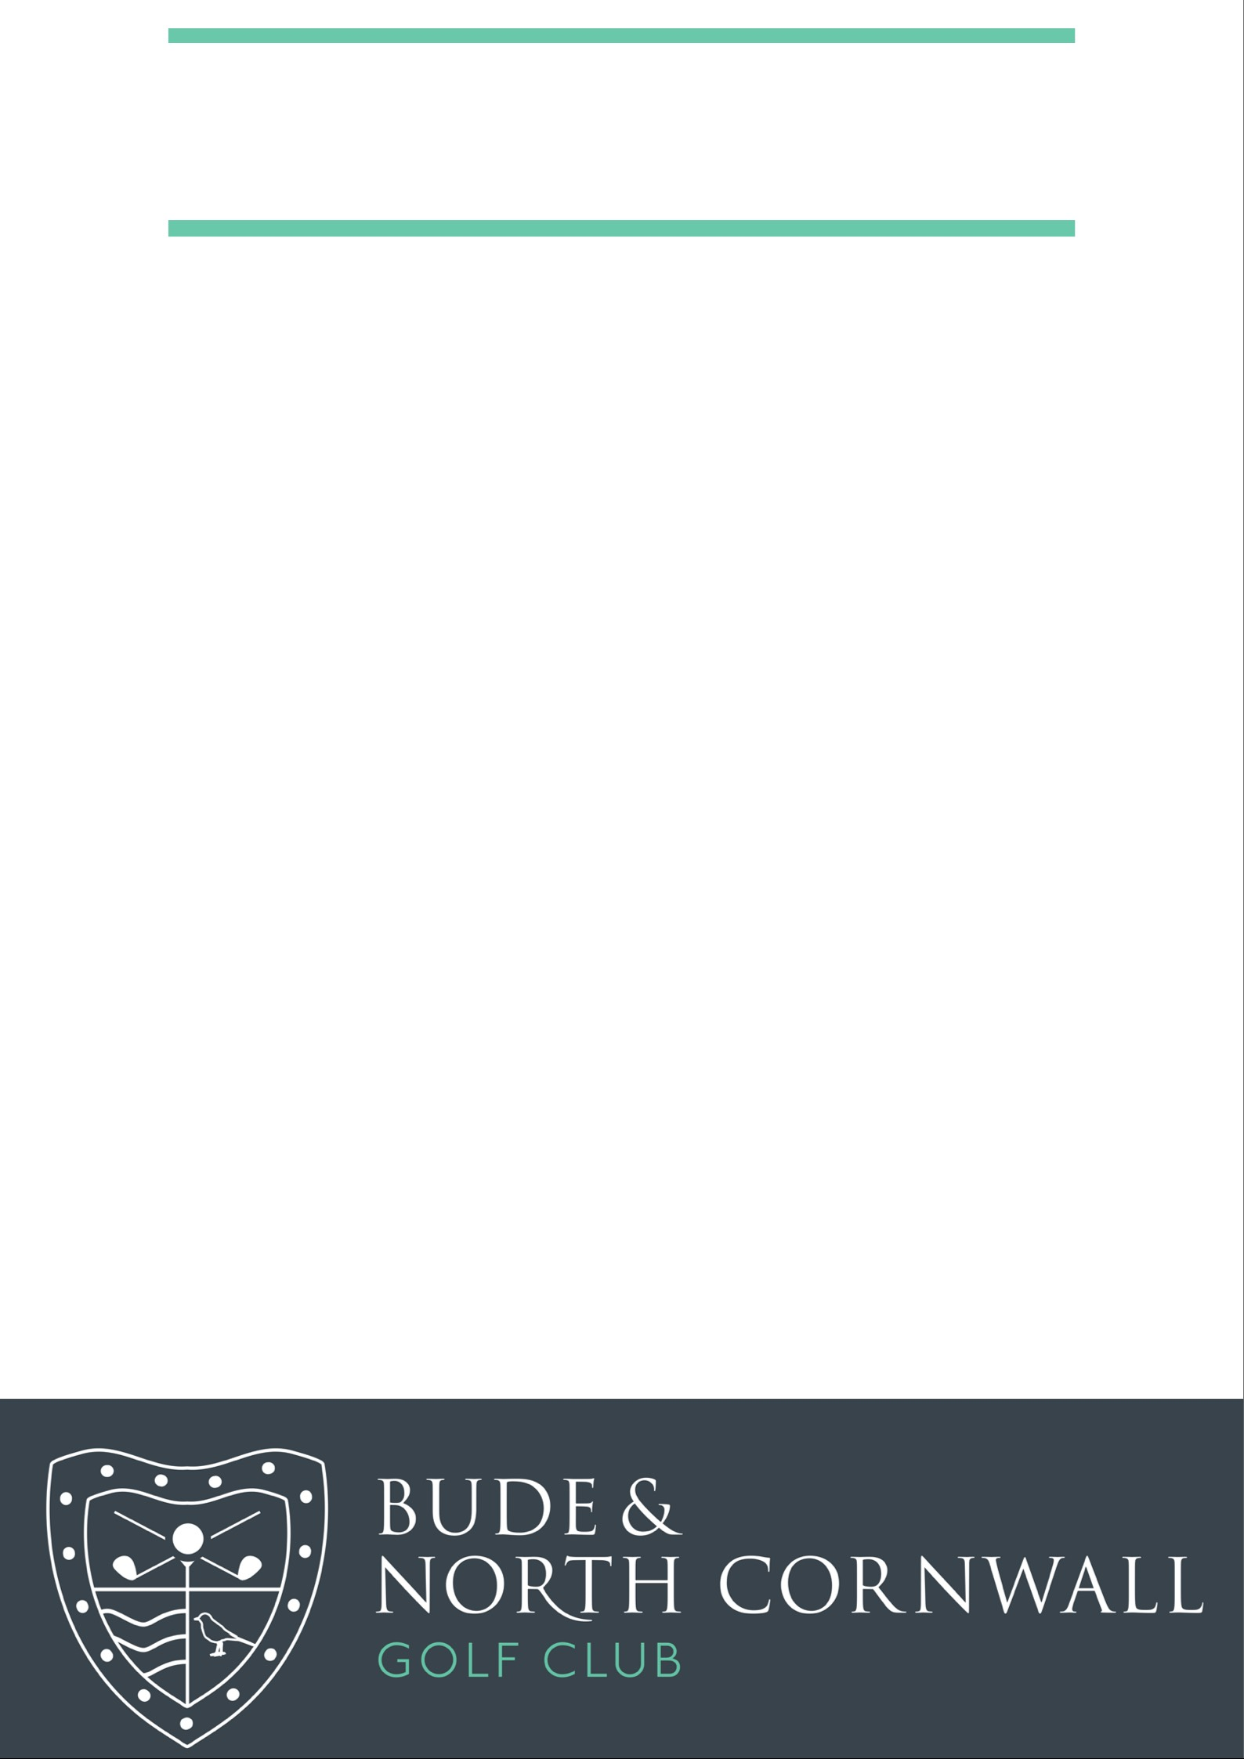

**Aria Resorts – Ladies Day**

**Results**

**1st**

**Mandy Congdon – Hana Dabrowski – Jo Tilbury – Jenny Perkins**

**89 Points (£24.00 each)**

**2nd**

**Jean Pearce – Collette Burgess – Jean Reed – Annie Quartermaine**

**80 Points**

**3rd**

**Liz Underwood – Kathy Cheeseman – Judith Smith – Salli Jago**

**78 Points**

**Twos’: Collette Burgess (8th) £24.00**