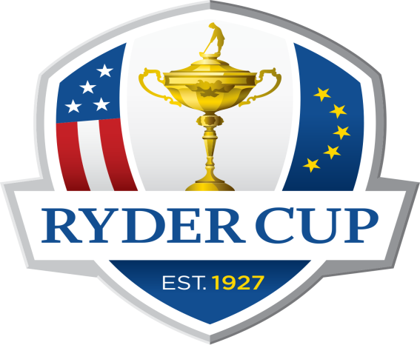
Sponsored by

Bude & NC Ryder Cup 2021
Time | Team Europe | Score | Team Points | Team USA | Score | Team Points
8.30 | Marcus Bryant  Morgan Bryant |  |  | Barry Gear  Matt Moore
8.40 | Robert Demott  Jeremy Horwood |  |  | Kit Hepple  Nick Brewer
8.50 | Dene Ferris  Chunky Philp |  |  | Jon Jaimeson  Simon Martin
9.00 | Adam Curtis (Captain)  Kelvin Davis |  |  | Kevin Dunster  Mark Penny
9.10 | Mark Duncan  Nick Wilce |  |  | Horace Parsons  Phil Davis
9.20 | Mike James  Terry Wilkinson |  |  | Tony James  Dave Simmons
9.30 | Jo Tilbury  Jenny Perkins |  |  | Jean Reed  Annie Quartermain
9.40 | Daryl Troop  Paul Anderson |  |  | Pete Giles  Lee Anderson
9.50 | Keith Merrifield  Graham Richards |  |  | Bimbo Wilcox  Spike Thorne
10.00 | Mark Morris  Peter Greatbatch |  |  | Steve Tilbury  Paul Haddon
10.10 | Henry Gywn-Thomas  Susie Currie |  |  | Hana Dabrowski  Emily Currie
10.20 | Tony Blatchford  John Percy |  |  | Doug King  Rolando Pearton
10.30 | Chris Underwood  Scott Collett |  |  | Simon Greatbatch  Scott Percy
10.40 | Paul Jillings  Judy Crabtree |  |  | Sharon Duncan  Chris Simmons
10.50 | John Vanstone  Collette Burgess |  |  | Steve Congdon  Mandy Congdon
11.00 | Will Gard  Dr Andrew Moss |  |  | Gary Chard  Rob Metherell
11.10 | Merv Hegarty  Andrew Pelling |  |  | Doug Holt  Dennis Mutton
11.20 | Lawrie Bridges  Jamie Burt |  |  | Gary Dinshaw  Greg Snowden
11.30 | Adam Bell  Steve Stritch |  |  | Dan Allen  Martin Turner
11.40 | Phil Newbery  Matt Mansbridge |  |  | Neal Tugman  Neil Bishop | `
11.50 | Andrew Finley  Andrew May |  |  | Steve Bartrop  Ray Downes
12.10 | Jon Vidler  David Downing |  |  | Alan Sheppard  Ken Vennard
12.20 | Shaun Parnell  Derek Bryant
12.30 | Maggie Hooper  Steph Smeeth |  |  | Kay Dinsdale  Mike Dinsdale
12.40 | Peter Calvert  Chris Hutt |  |  | Doug Thom  Glen Thom
12.50 | Gary Stone  Sandi Perry |  |  | Alan Pearce  Jean Pearce
1.00 | Jack Gear  Georgia Price |  |  | Mark Jenkins  Mark Biggs

Team Europe: Blue and Yellow
TeAM uSA: rED aND WHITE

4bbb stableford pairs
85% of your course Handicap
(The ph: (playing handicap) on your card is your handicap for the day)

